Application of nitrogen generator in food packaging and fruit and vegetable preservation industry

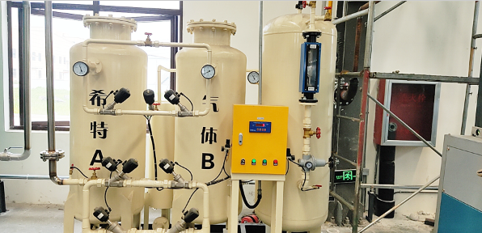
Customer site map

The role of nitrogen (nitrogen generator) in food industry for food preservation and food storage:
Nitrogen filled storage and preservation of fruits， vegetables and tea is also the most advanced method. This method can slow down the metabolism of fruits， vegetables and vegetable leaves in the environment of high nitrogen and low oxygen， which is like entering the state of hibernation and inhibiting post ripening， so as to keep them fresh for a long time. According to the experiment， apples stored in nitrogen are still crisp and refreshing after 8 months， and food preservation: nitrogen storage and preservation of grain， fruits and vegetables; Nitrogen filled fresh-keeping packaging of meat， cheese， pickled mustard， tea and coffee; Nitrogen and oxygen filling and preservation of fruit juice， raw oil and jam; Purification and covering of various bottles of wine， etc
Using nitrogen to keep grain in dormancy and hypoxia and slow metabolism can achieve good insect， mildew and deterioration prevention effects， and the grain will not be polluted，
Storing grains such as rice， wheat， barley， corn and rice with nitrogen exhaust air can prevent moths， fever and mildew， so as to survive the summer with good quality. In this method， the grain is tightly sealed with plastic cloth， first pumped into a low vacuum state， and then filled with nitrogen with a purity of about 98% until the internal and external pressure is balanced. This can make the grain pile lack of oxygen， reduce the respiratory intensity of grain， inhibit the reproduction of microorganisms， and all borers die due to lack of oxygen within 36 hours. This method of reducing oxygen and killing insects can not only save a lot of costs (about 1% of the cost of fumigation with highly toxic drugs such as zinc phosphide)， but also maintain the freshness and nutritional value of grain and prevent bacterial infection and drug pollution.
The cost of keeping apples fresh is about 10 cents per kilogram. Nitrogen filled storage can greatly reduce the loss of fruits in the peak season， ensure the supply of fruits in the off-season market， improve the quality of exported fruits and increase the income of earning foreign exchange. The tea is packed by air extraction and nitrogen filling， that is， the tea is put into the bag of double-layer aluminum platinum (or nylon polyethylene aluminum composite foil)， the air is pumped out， the nitrogen is injected， and the seal is sealed. A year later， the tea is fresh， the tea soup is clear and bright， and the taste is pure and fragrant. Obviously， this method is much better than vacuum packaging and frozen packaging.
At present， vacuum packaging and nitrogen filled packaging of frozen food are easy to deteriorate， and there are still many vacuum packaging that are easy to leak.

