Method of standard gas distribution

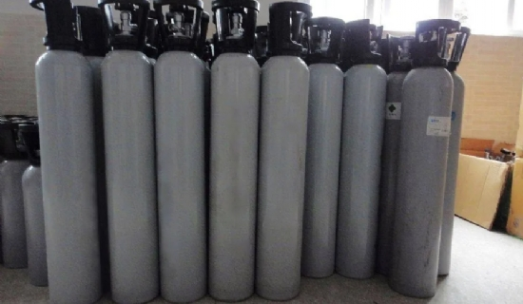
When only a small amount of standard gas is required， a 100 ML syringe can be used to prepare the standard gas; after several dilutions， the required low concentration of standard gas can be made. The concentration of the standard gas can be calculated based on the concentration of the original gas and the number of dilutions. The syringe used for gas dispensing must be gas-tight， with a small dead volume and an accurate system. A small piece of Teflon sheet is placed before the gas is dispensed and used for agitation.
Although the syringe gas distribution method is simple and easy to use， and the concentration of some standard gases is accurate， however， due to the adsorption of the syringe wall， large dead volume and incomplete volatilization of the liquid， the concentration of the prepared gas has a large error， and many standard gases of organic compounds are not suitable for preparation by this method. In the preparation of gases with volatile liquids， especially after the verification of qualified to prepare the gas with a syringe. The method uses a plastic bag as a container， and a certain amount of raw material gas is accurately measured with a gas quantification tube according to the diagram， and an appropriate amount of diluted gas is extracted by a syringe through a three-way piston and filled into the plastic bag， and the gas is mixed by repeatedly squeezing the plastic bag. According to the amount of raw material gas and diluted gas added to calculate the concentration of the standard gas in the bag.
When using plastic bags for gas， we should especially prevent the phenomenon of gas adsorption on the bag wall， reaction between the bag wall and gas and leakage. General plastic bags for most gases have obvious adsorption， can not be used for gas distribution. Usually choose polytetrafluoroethylene bags， polyester resin plastic bags and polyethylene film aluminum foil composite bags with gas.

