Cryogenic Nitrogen Plant Project

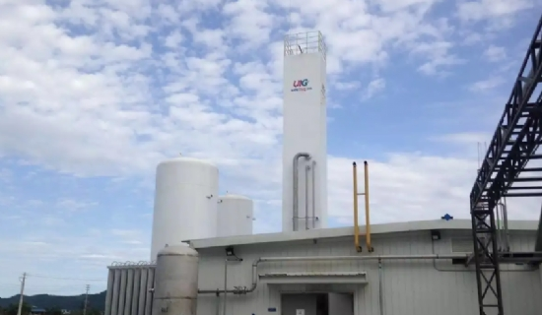
Cost of nitrogen generators - Nitrogen is a non-metallic element， denoted by the symbol "N". It is characterized by its non-reactive nature and has most applications in industry. In the periodic table， it has an atomic number of 7. This non-metallic element is tasteless， odorless and colorless. It is abundant in the earth's atmosphere， making up about 78% of the atmosphere. Undeniably， it is the most abundant element in the atmosphere. It is also said to make up about 3% of the mass of the human body and is said to be the fourth most abundant element in the human body after oxygen， carbon and hydrogen. This gas is widely used to make ammonia， nitric acid， organic nitrates， etc. This non-reactive element is a specialized industrial consumable gas.
Market Prospects
The outlook for the nitrogen consumption market is positive as the industrial gas market has been growing steadily at a CAGR of 12% over the past few years. Industrial gas plants are installed to generate industrial gases which are then piped to customers. For customers located in distant locations， the gas is delivered via cylinders. Due to the increase in industrialization worldwide， more and more nitrogen generators are being installed. Industrial nitrogen is mainly used in food processing， food packaging， technology， chemical， medical and agricultural industries.
Nitrogen Generator Project Report
The cost of setting up a cryogenic nitrogen generator project will depend on various factors， including land development， operating costs， etc. The cost of the plant will depend on its manufacturing capacity and the components used. The project report will provide detailed information on the capital investment， which will depend on the flow rate of the plant machinery. It will include all necessary information on contingencies.
Manufacturing process of cryogenic nitrogen
After providing you with information about capital costs and other expenses， the report also promises to give you a full understanding of the operation of the nitrogen generator. The plant is capable of producing two gaseous products， compressed nitrogen and liquid nitrogen. The compressed nitrogen is vaporized and then filled into cylinders.
The plant is manufactured using low-temperature air separation technology， which is considered to be the most efficient method of producing high-purity industrial gases. The raw material， i.e. atmospheric air， is taken to an air separation unit (ASU) where it is filtered.
It is then compressed in an air compressor and fed to a purification unit where impurities such as moisture， hydrocarbons and carbon dioxide are removed. The purified air passes through a series of heat exchangers where the feedstock is cooled to low temperatures by refrigeration.
The cooled air passes through a high-pressure distillation column. Here， the air is separated into oxygen and nitrogen， and the desired gas is collected and sent to a low-pressure distillation column for further distillation to achieve the desired nitrogen purity.
Raw Materials
In addition to the use of atmospheric air as a raw material， there are other consumable raw materials that will be used for the normal operation of the plant. These materials include grease， chemicals， catalysts and lubricants.
A detailed Cryogenic Nitrogen Generator Installation Cost Project Report will provide you with comprehensive information on all aspects of the plant. Get high quality nitrogen generation equipment at a competitive price.

