Nitrogen vs. air in tires - Benefits of filling tires with nitrogen

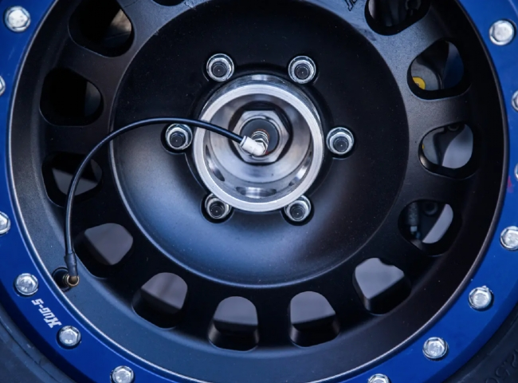
Today's modern gas stations， car dealers and automotive specialists are offering the option to fill their customers' tires with pure or higher concentrations of nitrogen (N2) with air.
Typical compressed air is made up of water vapor and various gases， including nitrogen， oxygen， carbon dioxide and argon. Nitrogen and oxygen make up the majority of the Earth's atmosphere.
In order to remain competitive， it is important to provide customers with the best options to meet their needs. Choosing a nitrogen-filled tire versus an air-filled tire can make a difference in the performance of your customer's tires.
Here are some important factors to consider.
Why use nitrogen in your tires?
Before you change the air in your tires with nitrogen， it is critical to understand the benefits of nitrogen in your tires.
What are the benefits of nitrogen in tires?
One of the benefits of using nitrogen in your tires is that it is cost effective over time. This is because tires filled with nitrogen have a more stable tire pressure - with a stable tire pressure， your tires are less prone to corrosion， which can cause them to deteriorate more quickly.
Does filling tires with nitrogen really work?
Since nitrogen is not affected by rapid changes in temperature， this means that your tire pressure is stable despite the speed of your car.
Nitrogen in tires with air

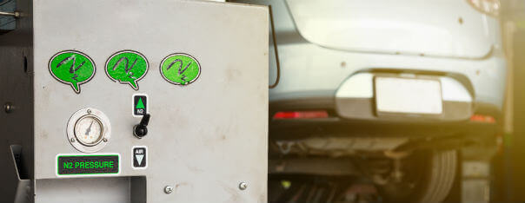
Deciding to inflate your tires with nitrogen instead of air requires an understanding of the differences between the two options. Here are some of the biggest differences between compressed air and nitrogen for tires.
Cost Difference
Nitrogen tire inflation is usually more costly than air tire inflation. This is because air pumps are more readily available and widespread than nitrogen pumps. However， having access to these products can save money over time when you have your own supply.
Air pressure maintenance
When you use standard pneumatic tires， you'll want to check your air pressure at least twice a year. This is because air will usually leak out over time due to improper adjustments. Nitrogen， on the other hand， is less likely to leach out of your tires. This means that you can expect tire pressure to remain more consistent in tires filled with nitrogen than in tires filled with compressed air.
Fuel Economy
If you keep your tires at the correct pressure， then you should get the best fuel economy. However， with standard pneumatic tires， your tire pressure may change simply based on the temperature outside and the speed you are driving at. These changes can affect your fuel economy.
For example， if your tire pressure drops， it will cause rolling resistance. Subtle rolling resistance will reduce your gas mileage. Because nitrogen is less responsive to changes in atmospheric temperature， you can maximize your fuel economy and get better gas mileage.
Aging Tires
The air in your tires is usually 78% nitrogen and 21% oxygen. Due to the low percentage of nitrogen concentration， oxygen retains moisture in the tires. This moisture causes oxidation of the tire wall casing， which leads to premature tire aging.
Special tires for aircraft， racing cars and heavy equipment

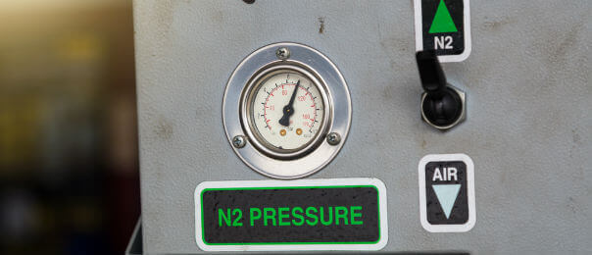
The tires of almost every race car， heavy equipment and aircraft are filled with nitrogen. Unlike consumer tires， this is necessary due to extreme temperature conditions.
Consider using a reliable nitrogen production product from a reputable supplier. Mobile nitrogen generators from Suzhou Hitech Gases can provide an economical supply of nitrogen for any professional， industrial or oil and gas application you need.
Final advice
From improved fuel economy to better air maintenance， there are several benefits to filling your tires with nitrogen as opposed to compressed air. It is important to use nitrogen tanks， generators， systems and other products from reputable suppliers such as Suzhou Hite Gases.

