Why are PSA medical oxygen generators vital to the medical industry?

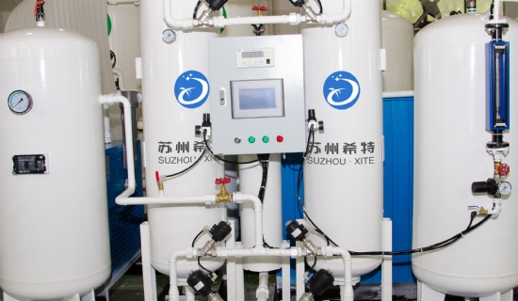
Variable Pressure Adsorption or PSA is a modern technology for on-site medical gas generators. Suzhou XITE has mastered this technology to produce the most medium to large PSA medical oxygen generators for customers in the medical industry. It can be installed in all hospitals and clinics， where patients get relief from their respiratory problems.
Advantages of using PSA medical oxygen concentrators
Save money on transporting oxygen cylinders
Heavy oxygen cylinders need to be transported from the market to the hospital by heavy vehicles. Hospitals need to spend a lot of money on this transportation. Now， the medical oxygen generator can solve this problem as it is installed in the hospital campus and can produce oxygen without interruption.
Low-cost oxygen production
The oxygen generator produced by XITE requires no raw materials other than air to produce large quantities of oxygen. Only electrical energy is needed to run this hospital oxygen generator， which is the only production cost that can get a large amount of oxygen in a short time.
Application of flawless technology
XITE's application of PSA technology to manufacture its oxygen generators has gained tremendous popularity. This PSA medical oxygen machine has proven to be very useful in providing the required amount of oxygen to many patients at a time. It separates pure oxygen by absorbing nitrogen from the air entering the unit.

