Nitrogen Membrane Units: Toward Efficient and Sustainable Gas Separation

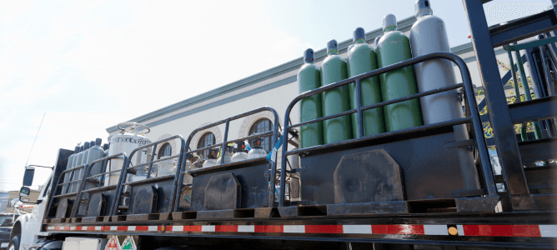
Nitrogen membrane equipment is an important tool in the gas separation process to improve efficiency and sustainability.
Nitrogen Membrane Equipment: Overview
Nitrogen membrane equipment is an advanced system used in gas separation processes. These plants operate on the principle of selective permeation， where nitrogen molecules pass through a semi-permeable membrane while other gases are rejected. Utilizing this technology， Nitrogen Membrane Plants offer a variety of benefits， including increased efficiency and sustainability.
A significant advantage of using nitrogen membrane equipment is the ability to provide high purity nitrogen gas. With nitrogen purity as high as 99.5%， these units are ideal for a variety of industries， including oil and gas， chemical， food and beverage， and more. With nitrogen membrane equipment， companies no longer need traditional nitrogen cylinders or expensive nitrogen generators， reducing logistical challenges and operational expenses.
Nitrogen membrane equipment has been successfully used to improve operational efficiency and reduce environmental impact. These devices help professionally minimize downtime， corrosion， and the frequent maintenance needs associated with traditional gas separation methods. By utilizing membrane technology， companies can achieve efficient gas separation without relying on energy-intensive processes such as pressure swing adsorption (PSA) or cryogenic distillation.
Key Components and Operation of Nitrogen Membrane Plants
Nitrogen membrane plants utilize hollow fiber membranes to selectively separate nitrogen from other gases. Key components of these plants include compressors， membrane modules， and nitrogen outlets. Through a selective permeation process， nitrogen molecules pass through the membrane while the other gases are retained.
Unlike energy-intensive cryogenic distillation processes， these plants eliminate the need for such methods， making them more cost-effective and environmentally friendly. In addition， their compact design and modularity make them suitable for a variety of applications， including gas purification and nitrogen production.
By using nitrogen membrane plants， industries can obtain high-purity nitrogen without the logistics and downtime associated with traditional nitrogen cylinders. In addition， membrane technology ensures that impurities such as carbon dioxide and water vapor are removed， thus providing a clean supply of nitrogen.
The importance of efficiency and sustainability in gas separation processes
Efficiency and sustainability are key factors to consider in gas separation processes. Nitrogen membrane plants offer a number of advantages in this regard. Efficiency is improved by membranes selectively permeating nitrogen molecules， leaving other gases behind. By utilizing membrane technology rather than traditional methods such as adsorption or pressure swing adsorption (PSA)， nitrogen membrane plants reduce energy consumption and eliminate the need for air compressors or molecular sieves. They provide a cost-effective solution for generating high-purity nitrogen.
In addition， nitrogen membrane plants offer environmental advantages. By relying on membrane separation rather than combustion or cryogenic distillation， these plants significantly reduce greenhouse gas emissions. They also avoid the logistical challenges and safety risks associated with handling nitrogen cylinders or liquid nitrogen.
As sustainable practices become increasingly important， nitrogen membrane equipment holds great future potential for advancing gas separation technology.
PSA vs. Membrane Separation Methods
When it comes to separating nitrogen from air， two commonly used methods are PSA (Pressurized Pressure Adsorption) and membrane separation. PSA utilizes adsorbent materials to selectively absorb certain gases， while membrane separation relies on permeable membranes to separate gases based on their molecular size. Both methods have advantages and disadvantages， but are suitable for different application areas.
PSA is known for its high efficiency in high purity separations. It is often used where purity is critical， such as in the production of medical grade nitrogen or in the electronics industry. On the other hand， membrane separation is more suitable for low purity applications where separation requirements are less stringent. It is widely used in industries such as food and beverage， where lower purities are acceptable.
PSA systems can be more expensive than membrane systems in terms of operating costs and maintenance.PSA systems require regular regeneration cycles and may require the use of additional equipment such as air compressors and CMS (carbon molecular sieve) beds. In contrast， membrane systems are typically less expensive to operate and require less maintenance. They operate using a simple filtration process and do not require complex regeneration cycles.
Choosing between PSA and membrane separation methods depends on a variety of factors， such as the level of purity required， gas composition， and budgetary constraints. For applications requiring high purity nitrogen or other gases， PSA may be the preferred option if cost is not a major concern. On the other hand， if cost-effectiveness and ease of operation are important， membrane separation may be a better choice.
In summary， PSA and membrane separation are both effective methods of gas separation， each with its own advantages and considerations. Understanding the specific needs of the application and considering factors such as purity requirements and budgetary constraints will help make an informed decision.

