What are the benefits of using PSA nitrogen generators in the food industry?

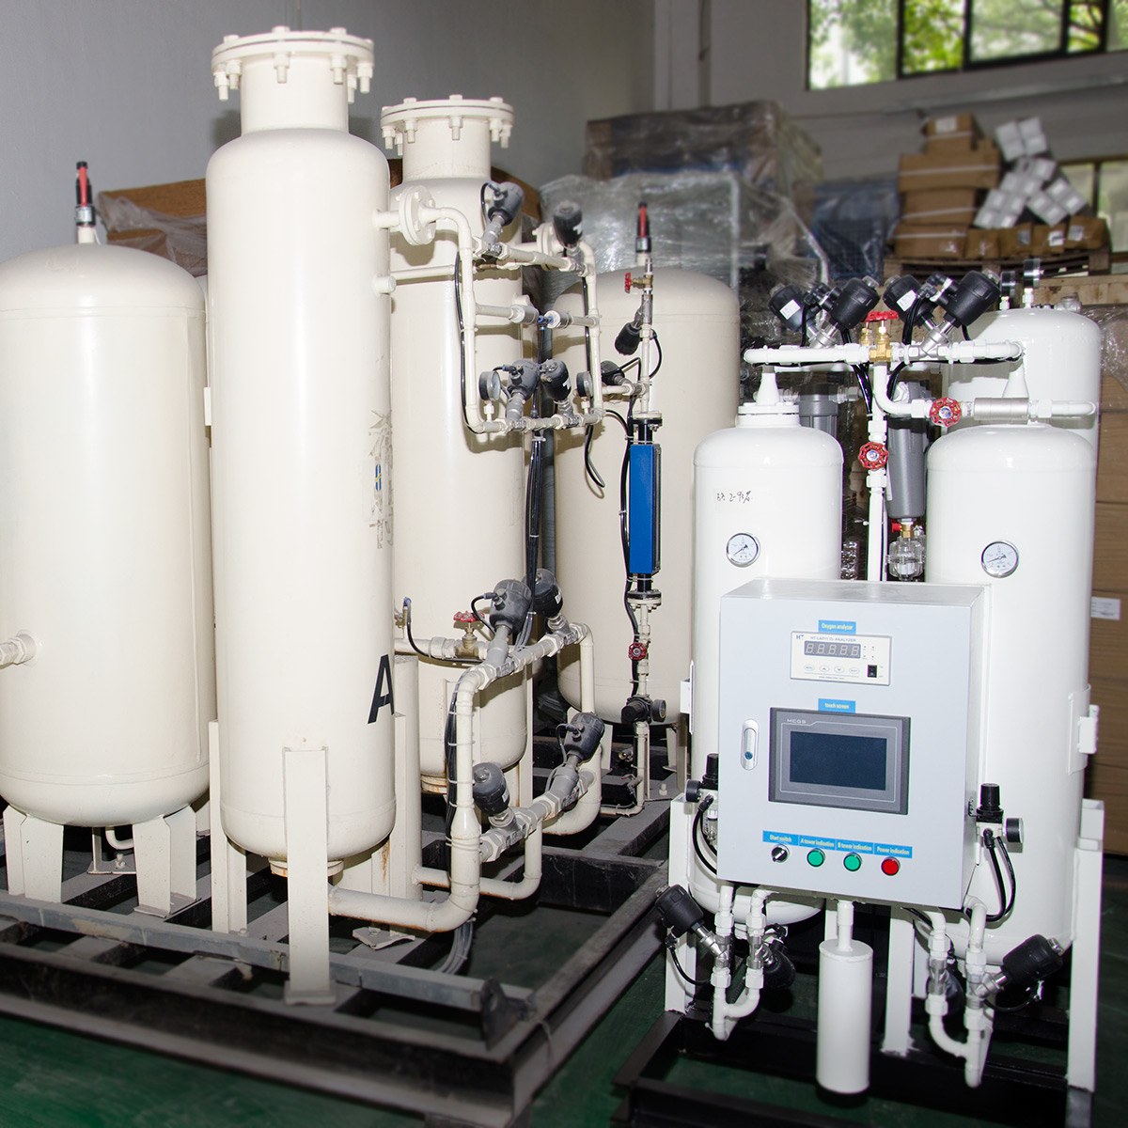
In this day and age， packaged food has taken over and people feel that packaged food is of better quality compared to unpackaged food. In order to maintain its freshness， smell and crispness and to keep it for a longer period of time， it is important to fill the space of the packaged food with nitrogen. Scientifically speaking， nitrogen is not a reactive gas and therefore it does not allow oxidation to take place， which can cause food to spoil or decay. Therefore， the food packaging industry uses nitrogen to give your food a longer life and keep it in proper condition.
Industries that deal with food and beverages absolutely need a constant supply of nitrogen so that the production process can continue. It can sometimes happen that， for some reason， the supply of nitrogen is delayed and this can cause problems for the food packaging process. It may not be a good idea to keep processed or prepared food products for a longer period of time， so it is necessary to have a constant supply of nitrogen. To overcome these problems， why not install a PSA unit so that the flow of nitrogen is not delayed or obstructed.
Another good reason is that having a PSA nitrogen production unit can be very economical. Ordering nitrogen cylinders， transporting them， storing them and then looking after them can be too stressful. One has to see that they are stored properly so that no leaks occur and invoices have to be kept up to keep an eye on the stock. All of this requires labour， day and night， so we recommend the installation of a PSA nitrogen production unit， which will make the whole nitrogen supply process more economical and easier.

