Nitrogen generators for oil pipeline pre-commissioning

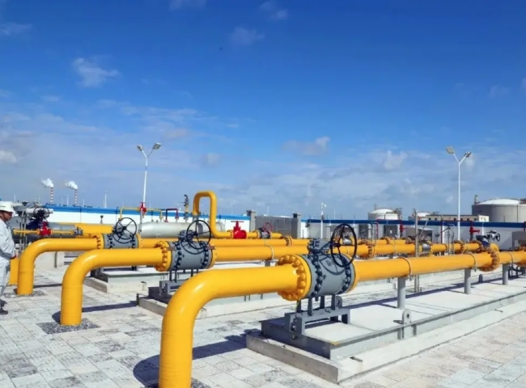
PSA Nitrogen Producer， Nitrogen Producer， Nitrogen
Suzhou XITE is a leading designer， manufacturer and supplier of PSA nitrogen generators. Nitrogen is widely used in pre-commissioning and commissioning activities such as nitrogen loading of oil and gas field pipelines， nitrogen purging， nitrogen drying and nitrogen pressure testing. For onshore and offshore applications， nitrogen inert gas can be produced very economically in the field.
In the past， pipeline construction companies typically built pipelines while pipeline service companies provided cleaning， testing， dewatering， drying， inspection and coating services. Now， these services are provided by the service company or the construction company itself.
Pipeline projects can have long sales cycles and can be delayed or even cancelled due to permitting， weather or construction delays. I will not explain the pipeline construction cycle in detail and will jump right to the 3 most common applications that typically occur before commissioning， during inspection and maintenance.
The dewatering process involves removing a significant amount of water from the pipeline. Typically， a pig is fed into the pipeline， driven by air， to push the water out. A high pressure compressor， booster and associated equipment are required. The maximum dewatering rate is defined by the customer， who in many cases collects water for environmental reasons.
Often， water remains in the pipe after it has been dewatered. Dry air enters the pipe under pressure and absorbs the remaining water in the pipe. Compressors and dryers with pressure dew points as low as -40 degrees Fahrenheit or even lower are usually provided to ensure the shortest possible drying time.
Cleaning and inerting procedures are typically performed in new natural gas pipelines. Nitrogen is injected into the pipeline and then the air in the pipeline is safely purged out. These procedures are essential. They not only replace oxygen， but also delay oxidation and avoid explosions by not allowing air and natural gas to mix in dangerous concentrations. Nitrogen generators with different flow rates and purity are matched with compressors and booster to achieve the desired nitrogen pressure and flow rate.

