Aquaculture industry by balancing the natural plankton， the technology has been successful worldwide

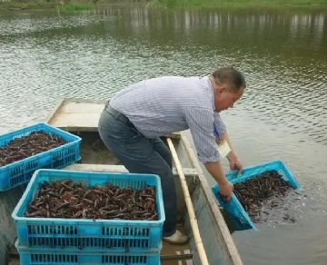
The prevalence of many diseases affecting the shrimp and prawn farming industry has promoted the development of various health management strategies. These include enhanced biosecurity and sourcing of pathogen-specific animals， as well as the use of chemicals and antibiotics in more extreme cases.

However， due to the nature of open pond culture， where most farmed shrimp are produced globally， it is often not possible to raise animals in a bubble by completely eliminating the presence of all pathogens.

In fact， the continued accumulation of sediment and subsequent deterioration of water quality in conventional pond systems is known to promote the growth of many pathogens， including the pathogenic Vibrio. Promoting the growth of microalgae can help maintain water quality， but this is difficult to manage， and these systems are prone to fluctuations in phosphorus and dissolved oxygen that can stress animals.

This technique was introduced to solve some of these problems. This is achieved by adding additional carbon to the water， thereby converting potentially harmful organic matter and sludge into consumable biomass， a process that eliminates or greatly reduces the need for water changes and is therefore more environmentally friendly， while also providing greater biosecurity.

However， biofloc technology has been successful around the world; the operating costs to maintain continuous suspension of bioflocs can be significantly higher. A potentially more balanced approach between the use of microalgae and bioflocs in aquaculture is called water-mimicking technology. In this article， I present a brief description of the protocol and the implications of its use to help farmers consider this concept， which I believe will become a widespread standard practice in the industry.

