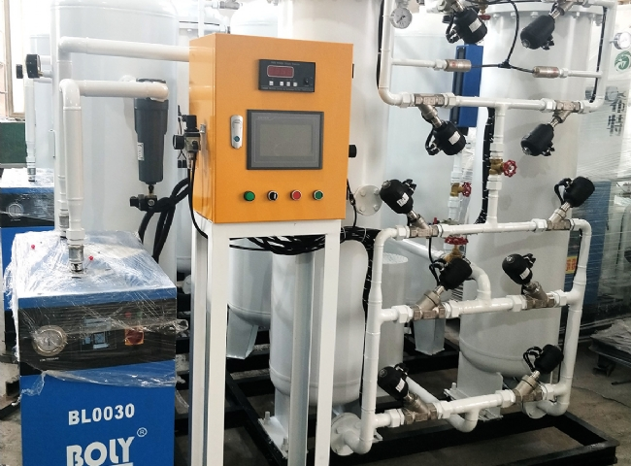
When our customers come to inspect the equipment they have customized to be sent to them， the feeling is all good.
This large 1000 m3/h PSA nitrogen generator plant， designed for 99.99% purity， recently completed the manufacturing and testing of the plant in XITE's workshop.
The equipment was designed for a fertilizer manufacturing company in China. The customer required large quantities of nitrogen for its catalyst regeneration process.
It was almost impossible for the customer to source bulk nitrogen as the investment to install a cryogenic plant would have been huge. Our client's engineering consultant recommended that they install a PSA nitrogen plant to meet their requirements.
PSA nitrogen technology is well established and in the PSA process， nitrogen is produced by extracting nitrogen from the atmosphere， which already contains 78% nitrogen. In the PSA process， 21% of the oxygen in the air is removed and released back into the atmosphere.

