How is liquid nitrogen produced from the gas?

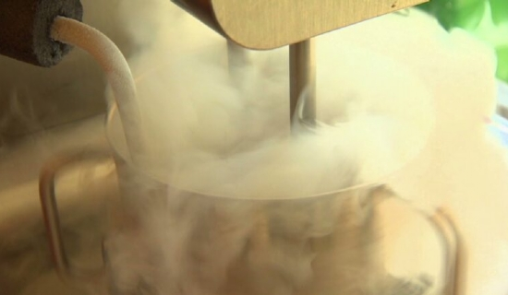
Liquid nitrogen is produced by air separation equipment as oxygen is produced by air separation equipment by liquefying atmospheric air and separating oxygen by uninterrupted low temperature distillation of nitrogen. The manufacture of nitrogen begins with the ASU manufacturing process in the main air compressor and ends with the output of the product storage tank. The air is compressed and then directed to a purification system where moisture， carbon and hydrocarbons are avoided. Afterwards， the air passes through a heat exchanger and is cooled to a low temperature. The air then enters a high-pressure distillation column， where it is transformed into the vapor form of nitrogen at the top of the column and is then transferred to a cryogenic storage tank.
Applications of nitrogen -
Nitrogen is one of the specialized industrial gases and is used in many industries.
Light bulbs - Nitrogen is used in the manufacture of light bulbs. It is a cheap alternative to argon gas in incandescent bulbs.
Packaged foods - Nitrogen is used to preserve the freshness of packaged foods. It prevents oxidation of food products.
Fertilizer - Nitrogen is used to make ingredients that increase soil fertility.
Electronic Components - Nitrogen is used in the manufacture of transistors， integrated circuits and diodes.
Stainless Steel - Nitrogen is also used to make stainless steel.
High Pressure Equipment - Dry， pressurized nitrogen is used to make high pressure equipment.
Liquid nitrogen is nitrogen that is in a liquid state at low temperatures. It is produced in our liquid nitrogen plant， which is manufactured from high quality materials. In addition， liquid nitrogen is easily transported without pressure. Nowadays， liquid nitrogen is used in the preparation of cocktails because it cools the cups and freezes the ingredients. It is used in the transportation of food， cryopreservation of biological samples， and as a coolant for superconductors， and vacuum pumps. It is also used in cryotherapy to avoid skin abnormalities， to protect materials from oxygen exposure， etc.

