Nitrogen generator for tire thermal cracking， 99.5% purity， 5KG/CM2 working pressure， 10m3/h

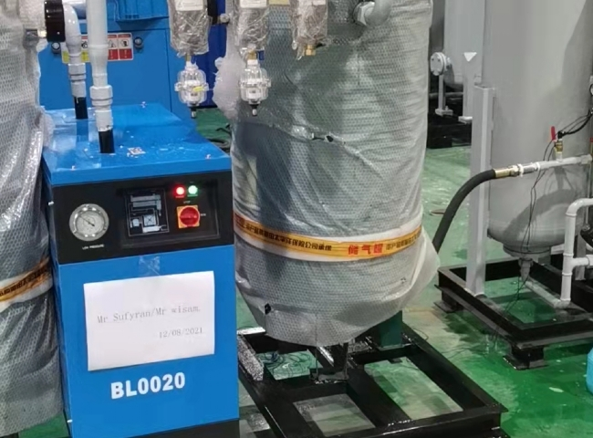
XITE Engineering Ltd. installed a 10 m3/h nitrogen generator for thermal cracking of tires with 99.5% purity and 5 KG/CM2 operating pressure.
The environmental and safety problems of these plants were caused by fire hazards， emissions of fine carbon particles and odor disturbances as well as the need to burn excess high temperature gas. To solve these problems， nitrogen is added to the reactor according to the process requirements and XITE has supplied nitrogen generators to many tire thermal cracking plant customers. Pyrolysis is a thermal degradation process that produces oil， pyrolysis gas (hot gas)， carbon black carbon and steel through the tire and rubber products in the absence of oxygen. During the pyrolysis process， the spontaneously generated pyrolysis gas is used as fuel and the tires are manually fed into the pyrolyzer and the steel wire and carbon are manually removed at the end of the process. This results in large carbon spills， exposure of workers to fine carbon particles and working in an unsuitable environment in the pyrolyzer. Some explosions have also been reported in some facilities due to frequent opening of the reactor in high temperature conditions.
The environmental and safety problems in these plants are caused by fire hazards， emissions of fine carbon particles and odor disturbances and the need to burn excess pyrolysis gases.
To overcome these problems， nitrogen is added to the reactor according to the process requirements and Seagate has supplied nitrogen generators to many tire thermal cracking plants.
The range of tire thermal cracking products sold by Suzhou XITE is as follows
MODEL | CAPACITY m3/h
XTFD-10 | 10 m3/h

