Nitrogen is widely used in the pharmaceutical industry for covering， handling and packaging

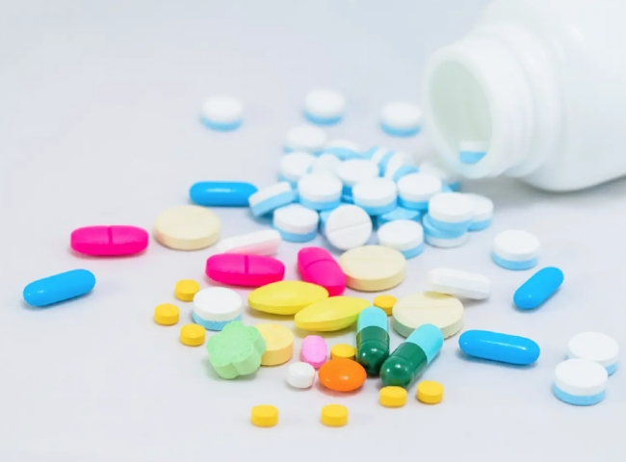
Pharmaceuticals is a very diverse industry. As such， nitrogen is used in many different processes and applications， starting with basic raw material preparation and continuing through to final product packaging.
First， let's understand the properties of nitrogen and why it is used. Nitrogen has the properties of an almost inert gas， and nitrogen reacts very difficult with other elements. Nitrogen is available in large quantities. Atmospheric air is composed of 78% nitrogen and 21% oxygen， with the rest being other gases in lower concentrations. This abundance and the ability to easily separate nitrogen from other gases using the PSA nitrogen process and cryogenic separation processes means that nitrogen is a relatively inexpensive gas that can be produced in large quantities at high purity levels.
In pharmaceutical industry production， raw materials such as APIs， inactive ingredients and other chemicals that may be sensitive to oxygen need to be preserved in an inert atmosphere to prevent exposure to oxygen and subsequent spoilage due to oxidation. In the storage and processing of such oxygen-sensitive materials， nitrogen is used as a filler gas， a purge gas， and also as a gas to move products in pneumatic conveying systems. Nitrogen is often used in the transfer of pharmaceutical products. The use of a safe inert gas for transferring liquid or powdered pharmaceutical materials is necessary because these materials can be dangerous if not handled properly.

