Nitrogen generators for chemical coverage (PSA nitrogen generators， nitrogen equipment)

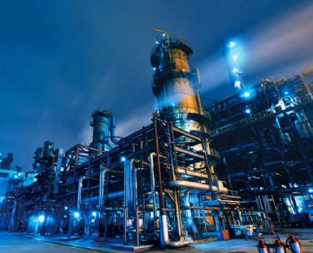
It is common for many industries (including chemical and refineries) to store liquids and gases in storage tanks. However， it is important to note that oxygen degrades and oxidizes， and this can create potentially explosive and hazardous situations if stored materials， such as flammable liquids， come into contact with oxygen. This makes it imperative that industries storing hazardous materials adopt a method to prevent fires or explosions in their storage tanks. With nitrogen and a chemical cover， you can provide the ideal protection for your tanks while protecting the contents inside.
How Covering Works
Nitrogen and chemical overlay (sometimes called tank filling) is the ideal application for generated non-cryogenic nitrogen. It applies nitrogen to the empty space in your storage vessel and effectively reduces the actual oxygen in the vapor space. This process deactivates the oxygen while successfully eliminating the possibility of your tank catching fire or exploding.
Covering Methods and How to Best Protect Your Tanks
Producing your own nitrogen using an on-site nitrogen generator (PSA nitrogen generator， nitrogen equipment) is one of the most popular methods of supplying nitrogen coverage. However， when making your own nitrogen on site， in addition to what size generator you need， you will also need to determine how to cover your tanks.
When it comes time to decide how to cover your tanks， there are several options to choose from. You can use continuous purge coverage methods， concentration-controlled coverage， or pressure-controlled coverage. Continuous purge override is the most common technique and is simple to set up and does not require a control device or control loop (but nitrogen consumption can be high). Concentration controlled overrides do require a feedback loop to turn the generator on and off， but nitrogen is also used more efficiently. If you are using a pressure controlled override， a valve and pressure regulator control your nitrogen level.
The size of the generator you need will depend on the amount of liquid lost during pumping and the amount of tank vapor condensation that occurs during atmospheric thermal cooling. Based on this information， XITEch Gases can help you determine what size generator you need.
Benefits of nitrogen and chemical decontamination
Using the overlay method prevents the formation of a vacuum in the tank， maintains a consistent pressure， and reduces most evaporation of stored material. This method can also help you save more material while significantly reducing emissions. Covering also has the potential to make your equipment last longer， and you never have to worry about refilling or replenishing because of the constant production of nitrogen.

