National standards for various industrial gases

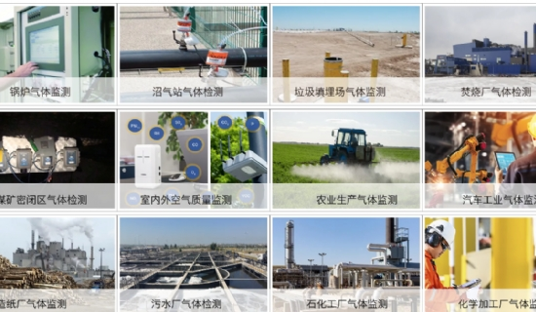
The national standards of various industrial gases vary， and only industrial gases that meet the national standards are considered qualified industrial gases. The following is a brief introduction to the standards of several commonly used industrial gases.
The national standard for hydrogen is GB/T7445-1995， in which the impurity content of pure hydrogen 99.99% is less than or equal to 5pm for oxygen and argon， less than or equal to 60ppm for nitrogen， less than or equal to 5ppm for carbon monoxide， less than or equal to 5ppm for carbon dioxide， less than or equal to 10ppm for methane and less than or equal to 30ppm for water; the impurity content of high purity hydrogen 99.999% is 10 times less than that of pure 10 times less than pure hydrogen. The impurity content of high-purity hydrogen is 99.999%， argon content is less than or equal to 2ppm， nitrogen content is less than or equal to 5ppm， carbon dioxide content is less than or equal to 0.5ppm， total hydrocarbon content is less than or equal to 0.5ppm， water content is less than or equal to 2ppm; and the national standard of nitrogen is GB/T14599-93. T4842-1995， 99.99% pure nitrogen Impurity content less than or equal to 5ppm hydrogen， less than or equal to 10ppm oxygen， less than or equal to 5ppm carbon monoxide， less than or equal to 5ppm carbon dioxide， less than or equal to 5ppm methane， less than or equal to 5ppm water.

