Oxygen cylinders-Safe use of oxygen cylinders

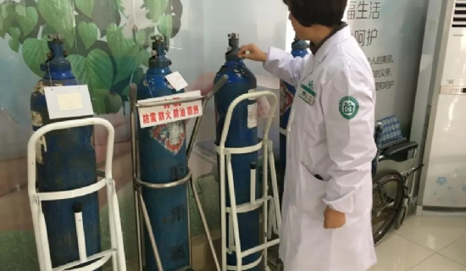
Oxygen cylinder is a special high-pressure container for storing and transporting oxygen， which is composed of four parts: cylinder body， cylinder hoop， cylinder valve and cylinder cap. There are two shockproof rubber rings on the outside of the cylinder body， and the cylinder body is sky blue and marked with the word "oxygen" in black paint to distinguish from other cylinders. Oxygen as an ideal combustion gas， widely used in welding and cutting. As oxygen is a kind of mobile container containing combustion compressed gas， high pressure， frequent loading， unloading and transportation， the use of a messy environment， often make the use of oxygen cylinders in an unsafe state， once the cylinder explosion accident， will cause huge losses to people's lives and property.
A， at present in the use of oxygen cylinders and the management of the following major hidden dangers: 1.
1， over the inspection period filling. According to the original Ministry of Labor "cylinder safety supervision procedures"， oxygen cylinders must be tested every 3 years. The purpose is to check the safety condition of oxygen cylinders in a timely manner， the timely detection of defects and hidden dangers to avoid accidents. However， the current use of oxygen cylinders over the inspection period filling the phenomenon is more serious， to the safe use of a serious hidden danger.
2. Damage and loss of accessories. Oxygen cylinder accessories have a valve， hand wheel， bottle cap and shockproof rubber ring. The cap is to prevent the cylinder valve in the handling process was hit and damaged， or even broken so that the gas spurts out at high speed， pushing the valve and hand wheel forward at high speed to cause casualties. Anti-vibration ring is a kind of protection equipment to prevent gas cylinders from being hit， which requires a certain thickness and elasticity. Gas cylinder safety supervision procedures" clearly stipulates that when transporting and loading and unloading gas cylinders， must be equipped with a good protective cap. But in actual use in the oxygen cylinder accessories complete very little， most of the bottle cap， hand wheel， bottle valve scarred， the stem was bent， or even seriously deformed， to the safe use of serious threats.
3. Sun exposure. "Gas cylinder safety monitoring procedures" provides that the cylinder transportation， summer use should be prevented from exposure to the sun. Because the volume of oxygen cylinders is limited， exposure will make the cylinder medium temperature rise， resulting in a sudden increase in pressure inside the cylinder， so that the cylinder in a dangerous state. Some users do not take shade measures in transport， when using oxygen cylinders in the summer will be exposed to the sun. Especially in the summer road temperature often reaches more than 40 degrees， if the cylinder itself is defective， overfilled or hit each other， there is a risk of explosion.
4. Safety distance is not enough. "Gas cylinder safety monitoring procedures" stipulates that the use of oxygen cylinders must be 10 meters away from the open flame， storage and acetylene cylinders are strictly prohibited in the same room storage. Many users ignore this requirement， there are welding operations， oxygen cylinders from the welding point of the distance is not enough 10 meters， oxygen cylinders， acetylene cylinders stored in the same room phenomenon. Once the gas cylinder leakage， meet the open fire explosion， will cause irreparable damage.
5、Rude loading and unloading. Transport and use， the phenomenon of brutal loading and unloading is very common， such as short-distance transport， oxygen cylinders will be pushed down， and then roll along the ground; vehicle transport is not fixed， cylinders collide with each other， from the vehicle directly downward push， etc.. Such as a city oxygen machine with a car shipment of oxygen cylinders to an enterprise， unloading the oxygen cylinder pushed down to another cylinder impact， causing two cylinders exploded at the same time.
6， overfilled. Oxygen cylinders in the filling due to violations of operating procedures or operational errors caused by overloading， so that the cylinder pressure rises， and more than its allowable stress， and finally an excess of plastic deformation and explosion.
Second， the safe use of oxygen cylinders should comply with the following points.
In order to protect the safety of the use of oxygen cylinders， the state has promulgated the "cylinder safety supervision procedures" "dissolved acetylene cylinder safety supervision procedures" "permanent gas cylinder filling regulations" and other regulations and standards， the design， manufacture， inspection， filling and use of oxygen cylinders are made scientific and clear provisions.
1. The oxygen cylinder used must be produced by the national designated manufacturers. The new bottle must have a certificate of conformity and boiler pressure vessel safety supervision department issued by the inspection certificate.
2. Oxygen cylinders must be regularly tested in accordance with the provisions. Overdue cylinders are strictly prohibited to be filled.
3. Oxygen cylinders are prohibited to contact with grease. The operator can not wear work clothes with too much oil， can not use hands， oil gloves and oil tools to touch the oxygen cylinder and its accessories.

