Nitrogen is an essential gas for modern food packaging

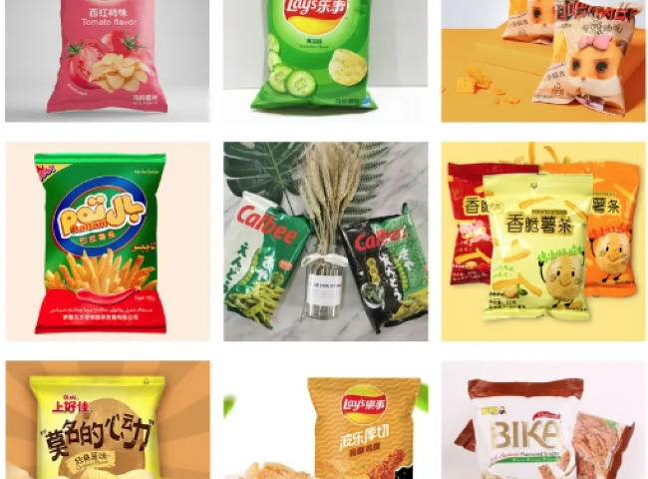

Nitrogen is becoming an increasingly important gas in the food processing industry. The main cause of spoilage in many foods is due to prolonged exposure to oxygen. Since air contains 21% oxygen， exposing food to air can lead to problems related to oxidation.
When oxygen is present， bacteria and fungi can grow in the food. This leads to food spoilage and possible rancidity.
In the modern food processing industry， it has become very important to prevent exposure of food ingredients and processed foods to oxygen.
While it is not possible to prevent oxygen exposure during the preparation of the food， it is possible to exclude oxygen during the packaging process before the food is shipped. Many food packaging machines now have an integrated nitrogen fill port that allows the food package to be cleaned with nitrogen or filled with nitrogen prior to sealing the package.
Nitrogen can extend the shelf life of food packages， sometimes by as much as three times. Nitrogen also prevents food from losing its texture， such as brittleness. This can be done with a XITE Nitrogen machine， which provides very dry nitrogen with a dew point below (-) 60 degrees Celsius， a dew point also known as the "backbone". Since it is impossible to reach such low temperatures in an air atmosphere， nitrogen does not condense.

