**Water treatment in steel plants**

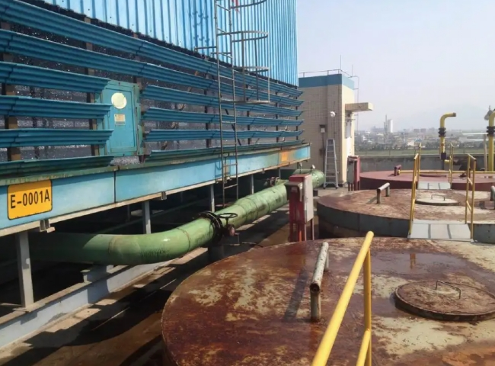

Water management in a steel plant

 Water is used in every plant of a steel mill and practically all functions of water are utilized in a steel mill. In steel plants， water is used for process and heat transfer purposes; while water losses in the process are unavoidable (evaporation， drift)， there is scope for further improvements in water use for environmental， energy efficiency， operational improvement and economic reasons.

The amount of water used in a steel plant varies considerably， depending on the availability of water， the technology used， the age and condition of the plant and equipment， the type of process and the operating procedures of the plant. Water recycling also varies considerably in integrated steel plants. Water availability is one of the main factors determining the recycling rate. Water consumption in steel plants is mainly through evaporation， ejected from cooling towers or incorporated into the product.

The various terms for water used in steel industry production are as follows.

Process water - It is the water that comes in contact with the final product or with the material incorporated into the final product.

Cooling water - It is water that is used exclusively for cooling purposes.

Boiler feed water - It is the water introduced into the boiler for conversion to steam.

Sanitary and service water - It is water used for drinking， showering， general cleaning and flushing of waste.

Intake water - It is the water that is pumped from the source to the steel plant.

Make-up water - It is water added to the water system to compensate for water losses.

Recycled water - It is water that is reused in a closed loop within the water system， usually after water treatment.

Effluent - It is the water that is discharged from the water system.

Consumptive water - It is the water lost through evaporation or incorporation into the product.

Total water use - It is the water equal to the make-up water plus the water circulating in the system.

Water for other uses - It is the water used for dust control， shop floor cleaning， gardening， etc.

Most of the water used in a steel plant is for cooling， protecting equipment and improving working conditions for employees. A small but still considerable amount of water is used as process water for iron ore beneficiation， purification of raw gases (coke oven gas， blast furnace gas and converter gas)， quenching of coke and slag， and descaling of steel. Process water is also used as part of chemical treatment， such as solvent for acid pickling， matrix for rolling emulsions， cleaning， degreasing or rinsing the surface of steel plates. Process water is also used for electrochemical treatments， such as zinc or tin plating. A small amount of water is used for boiler feed water and sanitary and service water. Water used for dust control is categorized as other uses.

The amount of water used varies greatly from one steel mill to another. This wide variation depends on the access to water and is largely determined by geographical location and local regulations. A global survey of steel mills showed that input water figures ranged from 1 to over 148 cumulative/ton of crude steel， and discharge water figures ranged from 1 to 145 cumulative/ton of crude steel. Make-up water requirements depend on the facility's water treatment and recirculation facilities and typically range from 2 to 4 cubic meters per ton of crude steel.

There are many aspects of water management that are important to the steel industry. The following are these aspects.

Water as a medium for heat transfer and therefore related to energy efficiency

The source of water， in terms of quality and quantity

Water treatment and circulation， recirculation systems

Water balance and water flow diagrams

Costs associated with water

The level of water quality depends on the process of its use

Development of water treatment technologies

Trends in effluent (biological oxygen demand， chemical oxygen demand and suspended solids， etc.) are moving towards higher standards

Water softening needs to be optimized on a per-process basis

Water use raises specific health and safety issues as well as environmental concerns

Water is a major component of sludge and brine， which raises specific disposal issues as untreated landfills are becoming less and less available， even on a temporary basis.

Despite the enormous importance of water to steel plants， the way it is used is not standardized， as is the production process in steel plants. There is no "one-size-fits-all" strategy or technology for using water in each particular case. Of course， each steel mill has a better understanding of its own water use and usually reports to regulatory agencies to demonstrate compliance with regulations and facility operating permits.

Water treatment technologies are evolving and the goals set by environmental standards are being tightened. This trend is likely to continue in the future.

Water purification strategies at some steel plants often involve mixing wastewater from different sources， which may not be as effective as a specific， more targeted， case-by-case approach in terms of quality of water discharge and treatment costs.

Technologies in the water industry include a variety of water pre- and post-treatment technologies， i.e.， chemical (organic， inorganic， biochemical)， physical (membranes， etc.)， biological， electrolytic， high-temperature processes， etc. Although none of these technologies are new， they have been advancing on a regular basis. These technologies can be effectively applied in steel mills to accommodate environment-based regulations and reduce the cost of water.

There is a need for good effort and cooperation between steel mills and the water industry to develop innovative partnerships that will result in the highest level of effective water management at steel mills on an ongoing basis. There are six issues that are considered critical to both steel mills and the water industry. These issues are described below.

Developing process flow diagrams for steel plants - A process flow diagram is a schematic representation of the process flow， showing the equipment， the flows to and from the equipment， and the major process controls. The streams are numbered and the volume and mass flow rates of each stream are indicated along with the physical and chemical properties. The disposal streams associated with the water treatment plant are also shown. The direction of each stream is indicated， providing information on (i) the flow rate in kg/h under operating conditions; (ii) the flow rate in com/h under operating conditions; (iii) the operating temperature in degrees Celsius; (iv) the operating pressure in bar (absolute); the density in kg/cum under operating conditions; (v) the dynamic viscosity in mPa.s; and (vi) pollutant concentration in mg/l. The focus of developing a process flow diagram is to establish a mass balance of elements， masses and energies to describe the operation of the integrated steel plant water network， going down to the level of each process and the relationship between the different plants. This should also include procedures for measuring all key parameters that define the complete water system. With the measurement of key parameters， it becomes easier to control where needed. A typical preliminary water flow diagram is shown in Figure 1.

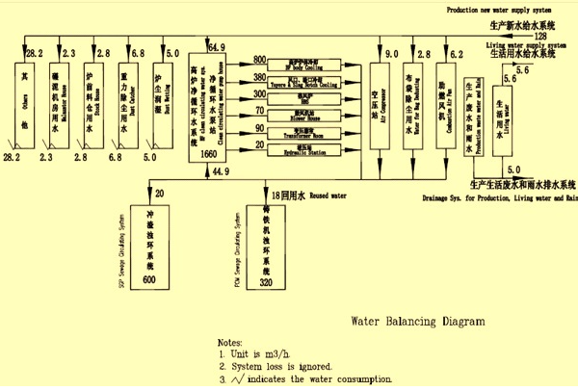

Figure 1 Typical preliminary water flow diagram

Current Water Treatment Technology Options - Both steel mill management and the water industry must consider applying smart manufacturing and process integration approaches to the design of steel mill water systems， with a particular focus on the renovation of existing facilities to achieve improved water management.

New technology concepts that use water as an energy transfer medium while minimizing energy disruption - Water is being used extensively to cool processes at temperatures sometimes up to 2，000 degrees Celsius to manage their smooth， reliable， fast， high-volume operation and to protect the integrity of equipment. The cooling technologies in use today represent some of the most advanced technology that modern engineering has to offer. However， the drawback is that it produces low temperature water or low pressure steam with much lower energy than that of the heat source. To better manage water， steel mills and the water industry must look for breakthrough concepts that perform the same demanding functions with the additional constraint of conserving energy and thus recovering higher quality energy for other uses.

Recovering products and resources from wastewater， brine and sludge - Water-containing residues from steel mills come from many process plants and are treated appropriately in terms of safety and water quality in preparation for discharge， while some residues that are primarily solids leave higher concentrations of process-generated auxiliary elements. With regulations driving reuse and recycling as a general principle of resource conservation， revisiting current practices in light of new regulations and emerging new treatment technologies is a logical step to keep facility practices in line with societal goals. Of course， some streams may exhibit such low concentrations that treating them may not make economic sense at this time， but new concepts are bound to emerge.

Simultaneous optimization of energy and water flows - Mezzanine analysis is in principle a powerful tool for optimizing water or energy flows， although their application in steel plants is still in its infancy. Simultaneous optimization of both flows and further extension of this concept to other environmental flows (impacts) constitute a fairly new multi-criteria optimization principle that needs to be developed in any steel plant.

Use of waste heat as a driver for separation technology - The approach proposed here is to look for positive synergies between waste and water treatment， for example using unrecovered high temperature heat to dry sludge. It is currently at a very primitive stage and innovative approaches will come from solving both problems at the same time.